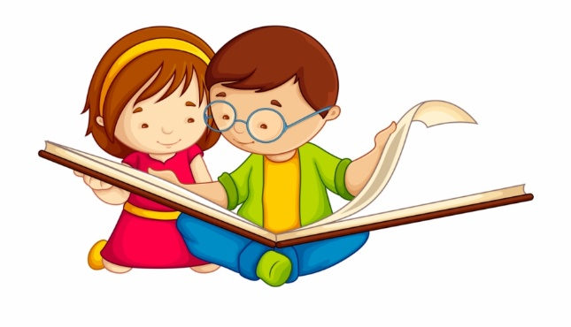

Letter of invitation for Families with Young Children
Dear Families,
We are doing a study about how a brother or sister helps a child with autism to learn. We also need families whose children do NOT have autism to help us understand what is the same and what is different for these families.
Families who have children who are , what is commonly referred to as, typically developing are invited to be in the study if they have a child who is between 2 ½ - 5 years old and another child who is between 2 ½ - 8 years old.
You will be assisting researchers to understand how children with autism learn and develop from playing and interacting with their siblings by being a comparison family. Your children will have fun playing games together and doing a number of interesting tasks. We will also provide you with a $30 Coles Myer Gift Card to thank you for your time.

If you are interested in participating, or finding out more, you can contact us in the following ways
- fill in the questions below and mail them to us at the address below, OR
- Contact Monica Cuskelly on (03) 6324 3461 or monica.cuskelly@utas.edu.au
- Contact Fiona Girkin on 0482 448 413 or fm.girkin@utas.edu.au
Or for Queensland
- Contact Virginia Slaughter on (07) 3365 6220 or vs@psyc.uq.edu.au

We are happy to talk to you about the study and give you more information.
Please let others know about our study if you think they would be interested in taking part.

I want to know more about the study.

My name is: ________________________________________________________

Please choose one of the following contact methods:

 | Post | Your postal address
 | Email | Your email address
 | Phone | Your phone number and the best day and time to call

Please post this form to one of the following addresses:

Tasmanian Families Queensland Families

Monica Cuskelly Virginia Slaughter
Locked Bag 1307 School of Psychology
School of Education The University of Queensland
Newnham Campus, Brisbane Q 4072
University of Tasmania
Launceston Tas 7250

